RESEARCH STRATEGY

BACKGROUND: Oropharyngeal squamous cell carcinoma (OPC) is one of the fastest-increasing cancers in the United States. It arises from the tonsils, base of tongue, soft palate, and posterior pharyngeal walls and now accounts for a growing proportion of head and neck malignancies. Approximately 60–70% of new OPC cases are attributable to human papillomavirus (HPV).¹ The incidence of HPV-positive (HPV+) OPC has risen steadily since the 1980s,² and in the past decade, HPV+ OPC has surpassed cervical cancer as the most common HPV-related malignancy in the country.³ Oral oncogenic HPV infection is a necessary precursor to HPV-associated OPC and therefore represents a crucial target for primary prevention through HPV vaccination.^{4,5} HPV vaccination has been proven highly effective in preventing persistent infection and associated malignancies. Since its introduction, population-level studies have shown significant declines in cervical, anogenital, and oral HPV infections among vaccinated cohorts, confirming durable immunogenicity and broad cancer prevention benefits.⁶ Yet, HPV vaccination remains underutilized among adults, particularly among men, despite their growing burden of oropharyngeal cancers. Only about one-third of adult males in the U.S. have completed the HPV vaccine series, compared to nearly half of females, leaving a large portion of at-risk adults unprotected.⁷
Veterans represent a population at uniquely high risk for HPV-related malignancies. Compared with the general population, Veterans are disproportionately male, older at the time of entry into Veterans Health Administration (VHA care, and more likely to smoke, live in rural and medically underserved regions, or experience occupational and environmental exposures such as burn pits. ^{8,9} More than one-third of enrolled Veterans reside in rural or highly rural counties, where access to specialty care and preventive services, including vaccination, is limited by geographic distance, workforce shortages, and transportation barriers.⁸ Rural Veterans have lower rates of cancer screening, later stage at diagnosis, and poorer survivorship outcomes, trends that may extend to HPV-related cancers.⁸ They also carry higher rates of comorbidities and mental health conditions that may complicate preventive care delivery. Epidemiologic analyses using VA and Surveillance, Epidemiology, and End Results Program data suggest that the increase in OPC incidence among Veterans is more than three times greater than in the general population.¹⁰ Despite these elevated risks, HPV vaccination uptake in the VHA remains strikingly low, with rates significantly below those observed in civilian populations (Figure 1). Emerging internal data indicate that vaccination rates are lowest among Veterans in rural Veteran Integrated Service Networks (VISNs), further amplifying geographic differences in preventable cancer burden. This under-vaccination portends a persistent and widening gap in HPV-associated cancer prevention within the VHA.
Figure 1: HPV vaccination prevalence among US Veterans aged 18 to 26 and number of veterans younger than 30 in each state
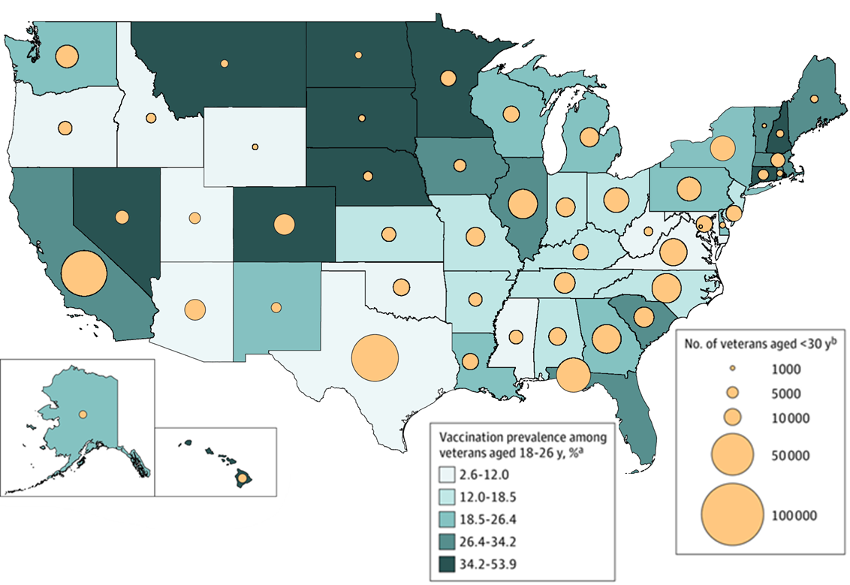
Although HPV vaccination is universally recommended through age 26, more recent guidance from the Centers for Disease Control and Prevention (CDC) endorses vaccination for mid-adults aged 27–45 based on shared clinical decision-making.⁶ The rationale for this selective approach reflects data from cost-effectiveness models developed in general U.S. populations: vaccinating mid-adults confers smaller marginal health gains at substantially higher costs per quality-adjusted life year (QALY) than adolescent programs, largely because of prior HPV exposure and existing herd immunity from younger cohorts.^{11,12} Nevertheless, several recent analyses demonstrate that extending vaccination to adults may provide meaningful population health benefits under certain circumstances. A global meta-analysis found that universal sex-neutral vaccination, including both boys and men, was cost-effective in high-income countries, with pooled incremental net benefits averaging US $9,370 per vaccinated individual for prevention of HPV-associated oropharyngeal cancer.¹³ Other studies have modeled specific high-risk populations, finding that adult vaccination can remain economically reasonable when baseline HPV prevalence is high or when targeted to groups with elevated infection or cancer risk, such as individuals who smoke or have immunocompromising conditions, and those with delayed access to preventive care.^{11,14,15}
Importantly, nearly all existing cost-effectiveness studies use general-population assumptions and fail to account for the demographic, behavioral, and clinical characteristics unique to Veterans. Unlike the general population, veterans receive care within an integrated health system. However, Veterans also often experience delayed engagement with preventive services, differ in baseline risk for HPV infection and OPC onset compared with civilians.^{9,16} These gaps are especially relevant for rural Veterans, who rely heavily on community-based outpatient clinics (CBOCs) where vaccination infrastructure and outreach capacity may differ from urban medical centers. Quantifying rural-urban differences in HPV vaccination across VISNs is therefore critical to designing equitable prevention strategies. For example, later age of first VHA encounter, higher smoking prevalence, and the absence of any screening test for oropharyngeal cancer could increase the relative value of vaccination in this population by preventing disease that otherwise would be detected only at late, costly stages.^{10,16}
From a health system perspective, the potential economic impact on the VA is substantial. Treatment for advanced OPC is expensive and associated with significant long-term morbidity, functional loss, and disability, generating considerable cost to the VHA in both direct care expenditures and indirect costs related to service connection and disability compensation.^{16,17} Modeling these downstream costs in relation to the investment required for expanded vaccination is critical to understanding the potential budget impact and return on investment in prevention.

SIGNIFICANCE: This proposal utilizes unique national VHA databases to enhance our understanding of HPV vaccination rates and trends in the U.S. Veteran population and to model how expanded vaccination could prevent cancer and improve cost-effectiveness. Understanding variations in vaccination rates across the U.S. and barriers within the VHA provides avenues for targeted intervention strategies. Notably, African American Veterans receive equitable treatment and survival outcomes within VHA institutions.¹⁸ However, disparities in vaccination uptake among rural and urban groups could continue to drive future inequities in HPV-related cancer burdens. This proposal aligns directly with the Office of Rural Health’s goal of improving access to preventive services for Veterans in underserved areas. Beyond measurement, the significance of this work lies in delivering actionable data to VHA leadership, VISN directors, and the National Oncology Program Office to inform prevention policies and resource allocation. Developing a regional specific metric, such as VISN-specific metrics, including vaccination prevalence, rural, urban stratified cost-effectiveness, and projected cancer burdens, will enable tailoring prevention efforts to local needs. These findings could support integrating HPV vaccination prompts into the VA’s electronic health record system, population health dashboards, or patient portals, directly enhancing preventive care delivery.
This proposal aligns with the Health Systems Research (HSR) Priorities of “Population Health and Whole Health” by focusing on understanding and improving HPV vaccination rates within the VHA, a proven method to prevent HPV-associated cancers. It also supports ORD-wide Research Priorities by utilizing existing VHA datasets (“put VA data to work for Veterans”) and incorporating real-world economic models (“increase the substantial real-world impact of VA research”) to guide vaccination policies and assess long-term benefits. Establishing a sustainable analytic framework, such as a potential Veteran Immunization Data Analytics (VIDA) platform, will ensure ongoing monitoring of vaccine uptake and outcomes across VISNs, providing lasting value beyond the funding period.

INNOVATION AND IMPACT: To the best of our knowledge, this is the first study to comprehensively evaluate HPV vaccination among Veterans, including barriers to uptake, population-level trends, and the projected health impact of expanded vaccination eligibility within the VHA. While vaccination patterns and cost-effectiveness have been extensively studied in civilian populations, applying these findings to Veterans is inappropriate for two main reasons. First, HPV vaccination rates in active-duty military and Veteran populations remain very low,¹⁹ compared to the general population, where vaccination coverage more than doubled between 2013 and 2018.⁷ CDC recently expanded HPV vaccination indications to include men and women up to 45 years of age, making many Veterans entering the VHA system newly eligible for vaccination.²⁰ However, there is currently no requirement or systematic program for HPV vaccination among active-duty personnel or Veterans,^{19,21} despite evidence that nearly one in five males in active service developed a new oncogenic HPV16 or HPV18 infection over a ten-year period.²² These data highlight an urgent need to evaluate real-world vaccination patterns within the VHA and identify populations at highest risk for under-vaccination. Second, Veterans have behavioral and clinical characteristics that increase their risk for HPV-associated cancers and may influence vaccine effectiveness. Smoking rates remain significantly higher among Veterans than in the general U.S. population,^{23,24} and the 2019 Survey of Veteran Enrollees’ Health and Use of Health Care reported persistently high rates of unsuccessful cessation attempts.²⁵ These risk factors, combined with older age at entry into the VHA, delayed engagement with preventive services, and a high prevalence of comorbidities, set Veterans apart from civilians and justify a Veteran-specific assessment of HPV vaccination value.
This study is innovative because it: 1) Shifts the focus of HPV-related cancer prevention to Veterans, a high-risk but understudied population for whom no vaccination policy currently exists; 2) Integrates real-world VHA data with decision-analytic modeling to estimate both clinical and economic outcomes of expanded HPV vaccination, providing the first Veteran-specific cost-effectiveness evidence; 3) Combines epidemiologic and health services approaches to identify barriers to vaccination, enabling tailored, VISN-level interventions that can be readily implemented across the VA system; 4) Establishes a foundation for predictive modeling infrastructure within the VHA, capable of informing future strategies beyond HPV, including other infection-related cancers.

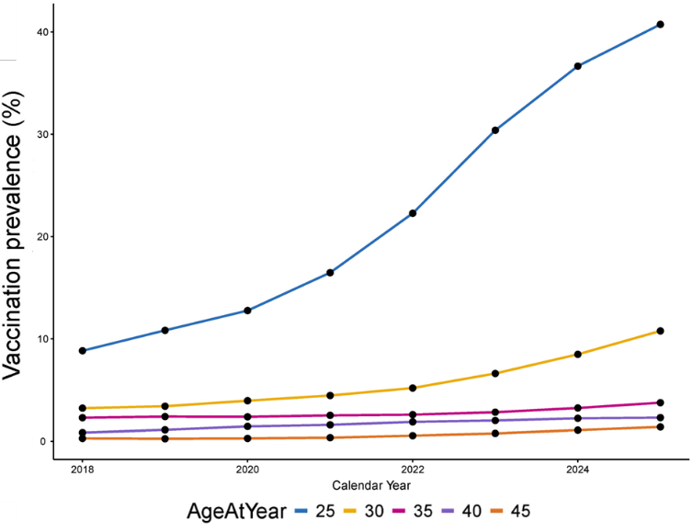
PRELIMINARY DATA: Our team published the first national analysis of HPV vaccination prevalence among Veterans aged 18–26 years using data from the VHA Corporate Data Warehouse (CDW) (Chidambaram et al., JAMA Oncology, 2023).²⁶ Among 128,279 Veterans with a primary care visit between 2018 and 2020, only 30.2% of females and 18.7% of males had received any HPV vaccination, compared with 62.4% of females and 37.0% of males in the general U.S. population. Vaccination rates were lowest among Veterans in rural regions and those from lower-income communities, and varied markedly by geography, from 6.1% in Wyoming to 53.9% in Hawaii, highlighting striking regional differences in preventive care for young Veterans. Building on this foundation, the current proposal expands the investigation to Veterans aged 26–45 years to evaluate vaccination trends in the population newly eligible for HPV vaccination under shared clinical decision-making guidelines. The prior study established the feasibility of using the VHA CDW and analytic infrastructure to assess vaccination patterns and predictors of uptake, providing the methodological basis for the present work. Extending this framework to older Veterans will allow us to quantify vaccination prevalence and trends, identify persistent rural and regional gaps, and model the public health and economic benefits of expanding HPV vaccination eligibility across the VHA.
Figure 2: Trends in HPV vaccination among veterans by age from 2018 to 2025.
HPV vaccination prevalence increased steadily from 2018 to 2025, particularly among younger Veterans aged 25–30, who demonstrated the highest uptake and fastest growth in vaccination rates (Figure 2). In contrast, vaccination prevalence remained substantially lower among Veterans older than 40, consistent with the upper age limit of shared decision-making recommendations. These temporal patterns demonstrate both expanding HPV vaccination coverage in the VHA and persistent under-vaccination among mid-adult Veterans—the exact population targeted by this proposal. This analysis confirms that HPV vaccination data can be reliably extracted from CDW immunization and pharmacy tables, validated longitudinally, and linked with demographic and behavioral variables. These findings demonstrate the feasibility of quantifying vaccination prevalence and adherence at the national level and provide the foundation for our proposed aims: identifying behavioral and VISN-level predictors of under-vaccination (Aim 1) and modeling the projected health impact of expanded vaccination eligibility (Aim 2). Together, these results establish both the analytic infrastructure and preliminary evidence necessary to support our Veteran-specific modeling of HPV vaccination and cancer prevention.
We developed and tested a fully functional Microsimulation Model (MM) to simulate the population health and economic impact of expanding HPV vaccination. The model represents a heterogeneous cohort of 10,000 simulated persons, or agents, characterized by age, vaccination status, HPV infection history, smoking behavior, and other risk factors that mirror the real-world VHA population. Agents transition through key health states, Healthy, HPV infection, Persistent infection, Cancer (HPV+ OPC), and Death, based on published evidence. The MM tracks HPV infections, OPC incidence, mortality, and healthcare costs across multiple vaccination policy scenarios, allowing direct comparisons of outcomes when eligibility extends to ages 26, 35, 40, and 45. As shown in Figure 3, extending vaccination eligibility consistently reduced cumulative OPC cases, deaths, and total healthcare costs, demonstrating the model’s capacity to generate biologically and economically plausible results. However, without better inputs from veteran-specific populations, these findings confirm the feasibility of our simulation framework, and its readiness for full-scale implementation in Aim 2, we require additional inputs to evaluate the projected health and economic benefits of HPV vaccination expansion in the VHA.
Together, these preliminary analyses underscore both the feasibility and the urgency of this work. Our team has successfully demonstrated the ability to extract, link, and analyze HPV vaccination data from the VHA CDW, generate robust population-level estimates, and integrate these findings into a calibrated simulation model that reflects the unique characteristics of Veterans. The observed increase in vaccination uptake among younger Veterans, combined with persistently low coverage in older age groups, highlights a critical prevention gap that can be directly addressed through the proposed research. Our modeling framework shows clear potential to project the long-term health and economic benefits of expanded vaccination eligibility, providing actionable insights for VISN- and system-level implementation. This foundation positions us to build a comprehensive, Veteran-centered evidence base to guide future HPV vaccination strategies, strengthen cancer prevention infrastructure, and ultimately improve health outcomes across the VHA.
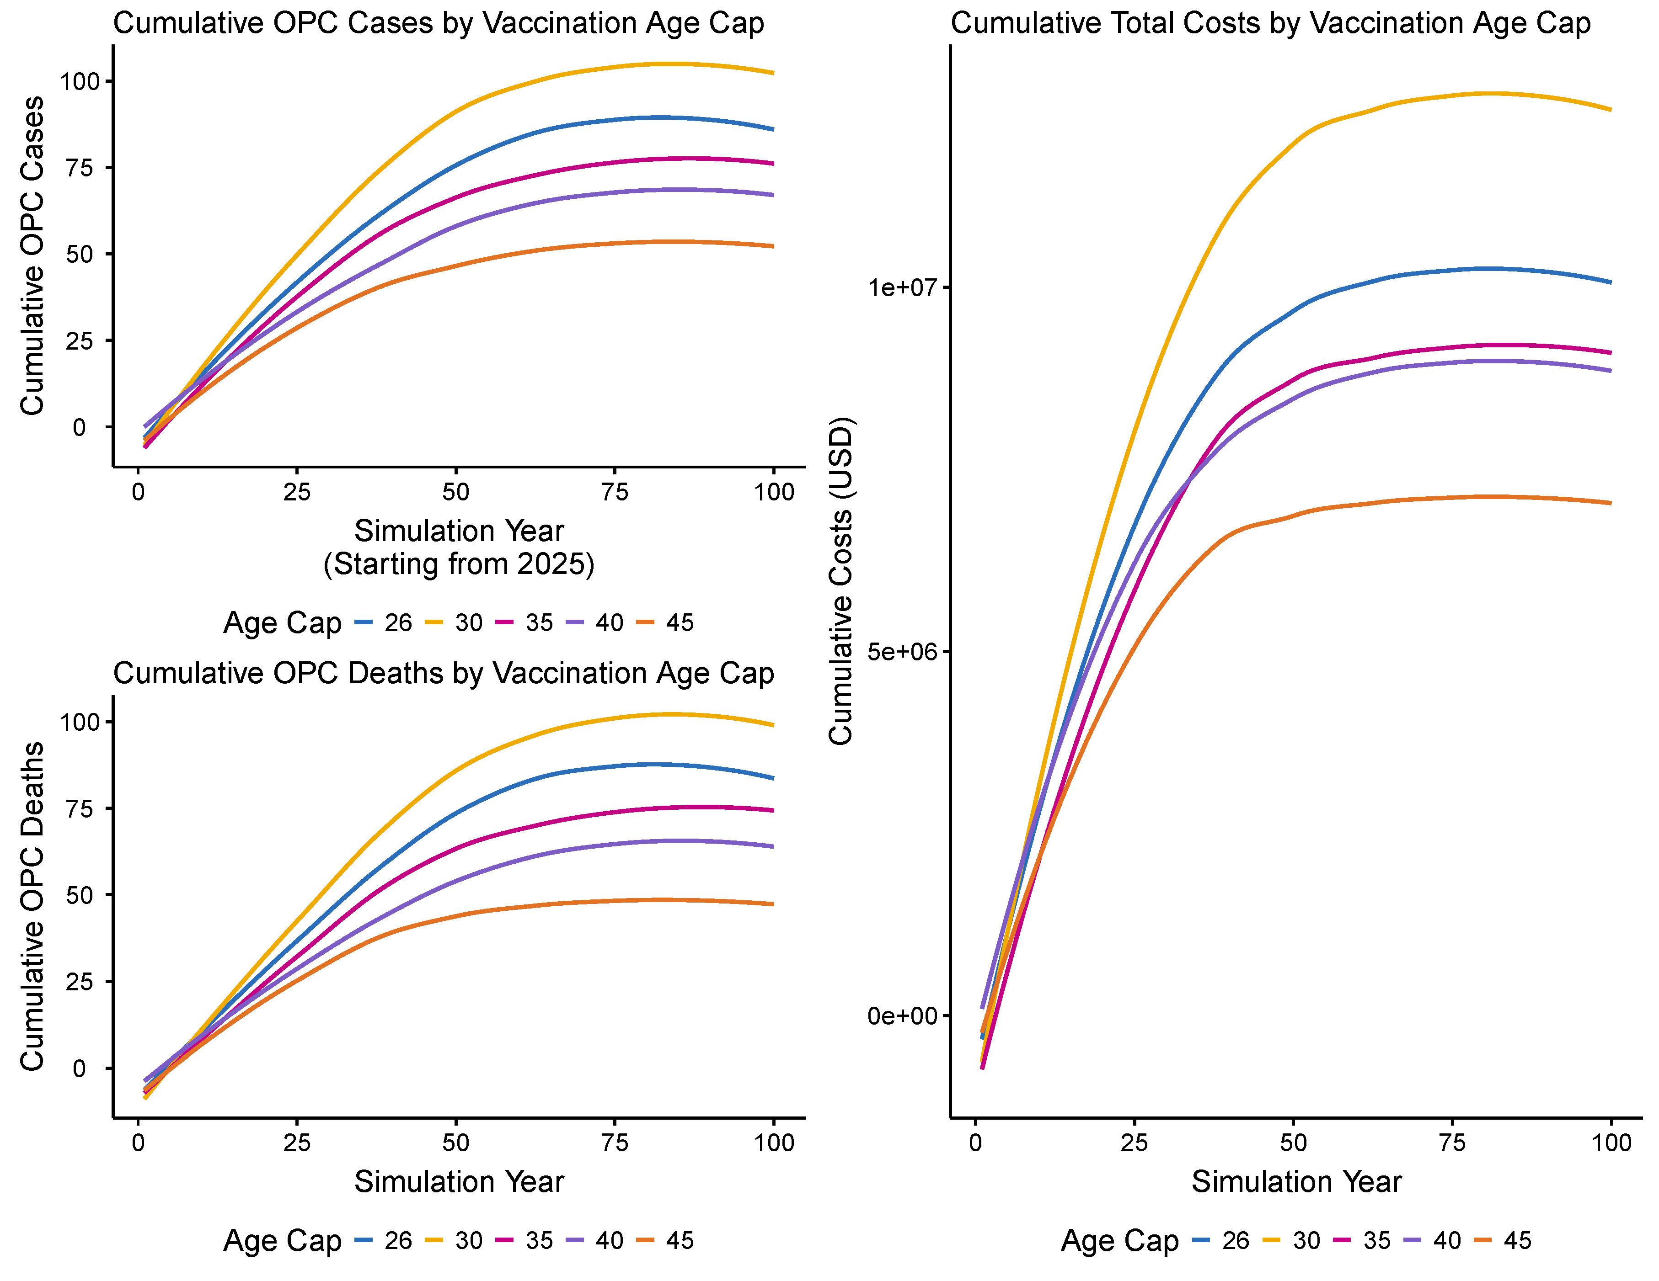
Figure 3: Preliminary simulation results from a microsimulation model of 10,000 Veterans show that extending HPV vaccination eligibility beyond 26 reduces A) OPC cumulative incidence, B) OPC death, and C) total health care costs.

RESEARCH DESIGN AND METHODS

Aim 1. Determine the overall prevalence of HPV vaccinated Veterans aged 26-45 and measure current trends in HPV vaccine administration by the VHA in this age group: Using data from the VHA CDW, we will characterize HPV vaccination patterns among Veterans aged 26–45 by estimating three complementary outcomes: the overall prevalence of HPV vaccination in this age group, the prevalence of Veterans who initiate HPV vaccination after age 26 in any healthcare setting, and the proportion of previously unvaccinated Veterans who initiate vaccination within the VHA after age 26. These measures provide a comprehensive understanding of mid-adult vaccination behavior, information that is critically needed because many Veterans enter VHA care in their late 20s or 30s, when HPV vaccination is no longer universally recommended but instead guided by shared clinical decision-making. Analyses will emphasize variation across census-tract Rural–Urban Commuting Area (RUCA), Spatial Access Ratios (SPARs), and VISNs, which together capture geographic and system-level differences in access to preventive services. We hypothesize that HPV vaccination rates among Veterans remain low overall, with especially low uptake among Veterans at elevated risk for HPV-associated oropharyngeal cancer—particularly White male smokers, individuals with heavy alcohol use, and those living in rural, highly rural, or low-access (low-SPAR) census tracts. By distinguishing between vaccinations administered outside the VA and those administered within VA facilities, this aim will identify which Veterans rely exclusively on the VHA for adult vaccinations and reveal geographic regions where structural barriers and low vaccination uptake converge. These findings will enable the development of targeted, VISN-specific vaccination strategies and prevention initiatives that can directly inform VHA population health and policy.
Experimental Approach: We will construct a national cross-sectional study of Veterans aged 26–45 who had at least one primary-care visit between 2018 and 2025, ensuring that all participants are actively engaged with the VHA and eligible for HPV vaccination. In 2017, approximately 6.1 million Veterans had at least one VA visit, of which 1.7 million were under age 45, indicating a robust population base for analysis. Using the VHA CDW, we will identify all eligible Veterans, extract immunization data, and link these records to demographic, behavioral, and geographic information to characterize vaccination patterns across the national VHA population.²⁷ In addition to this cross-sectional cohort, we will construct a longitudinal inception cohort of Veterans who reached the age of 26 during the study period and had no documented HPV vaccination before that age. These vaccine-naïve Veterans will be followed forward through VHA records to estimate the proportion who initiate HPV vaccination within the VHA after age 26, providing the first systemwide characterization of adult vaccination uptake under shared clinical decision-making guidelines. This dual-cohort design allows us to distinguish between vaccinations occurring anywhere and those attributable specifically to VA-based preventive care.
HPV vaccination prevalence and uptake: HPV vaccination records will be obtained from the CDW immunization and pharmacy tables. Because historical dosing information and exact administration dates are incompletely captured, especially for vaccinations given outside the VHA, our primary outcome for the cross-sectional cohort will be any HPV vaccination (yes/no), which provides the most reliable measure of vaccine uptake across the entire population. Within this cohort, we will also classify Veterans as vaccinated before age 26 or after age 26, allowing us to distinguish early-life immunization from mid-adult vaccination under shared clinical decision-making. Dose number and timing will not be used as primary indicators for the cross-sectional cohort due to incomplete data; however, they will be summarized descriptively when available. In contrast, within the longitudinal cohort of vaccine-naïve Veterans who turn 26 during the study period, we will be able to track vaccinations over time, enabling complete capture of dose number, dose timing, and adherence to the recommended series. For this cohort, we will measure series initiation, receipt of 1, 2, or 3 doses, and adherence (defined as ≥2 doses), as well as adherence to recommended dosing intervals when dates are available. This dual approach allows us to reliably estimate overall vaccination patterns across the VHA while also generating detailed, prospective data on dosing, adherence, and series completion among Veterans who initiate HPV vaccination within the VHA after age 26.
Behavioral, demographic, and contextual predictors: Behavioral and demographic variables will be derived from structured Health Factors and administrative data within the CDW and defined using validated phenotype algorithms from the VA Centralized Interactive Phenomics Resource (CIPHER) library to ensure reproducibility and consistency with VA data standards. Smoking status—a well-established risk factor for HPV-associated oropharyngeal cancer and a potential modifier of vaccine uptake—will be determined using the validated VHA Health Factors dataset, which is refreshed daily and routinely completed by providers in the electronic health record.^{28,29} Smoking will be categorized as current, former, or never at the index primary-care visit or within one year preceding it. To improve data completeness and validation, we will cross-reference smoking indicators with International Classification of Diseases, 10th Revision (ICD-10) codes and pharmacy data for nicotine replacement therapy or smoking cessation prescriptions. Alcohol use will be captured using Health Factors fields and ICD-10 codes related to alcohol dependence or abuse, while comorbidities will be summarized using the Charlson and Elixhauser indices calculated from inpatient and outpatient diagnosis codes to assess the relationship between chronic disease burden and vaccine uptake. Demographic variables will include age, sex, race/ethnicity, marital status, and service connection percentage, which collectively provide key contextual factors influencing preventive health behaviors. Service connection percentage will serve as a proxy for disability status and healthcare utilization intensity, while marital status may reflect differences in social support that affect preventive care engagement.
Geospatial measures, rurality and access to vaccination: Geographic analyses will link each Veteran’s residential address Planning Systems Support Group (PSSG) Geocoded Enrollee Files to the corresponding U.S. Census tract using VA’s validated geocoding algorithms within the CDW. This allows linkage of individual-level data to tract-level indicators of rurality, spatial access to care, and socioeconomic context. Rurality will be quantified using RUCA codes developed by the U.S. Department of Agriculture’s Economic Research Service and the University of Washington.³⁰ RUCA codes classify census tracts into 10 categories (1 = urban core, 10 = isolated rural) based on population density, urbanization, and commuting patterns. Following VA Office of Rural Health standards, these will be aggregated into four categories—urban, large rural, small rural, and isolated rural—consistent with existing VHA reporting conventions.
To evaluate geographic access to HPV vaccination, we will calculate SPARs at the census-tract level for all CBOCs and VA medical centers (VAMCs) that provide adult vaccination services.³¹ SPARs quantify accessibility by integrating clinic supply, Veteran population demand, and travel time. Using the Enhanced Two-Step Floating Catchment Area (E2SFCA) method, we will define supply as the number of VA facilities offering adult HPV vaccination and demand as the number of enrolled Veterans residing within each tract.³² The method accounts for overlapping service areas by weighting access based on travel time bands (0–20, 20–40, and 40–60 minutes) and applying distance-decay functions to reflect the decline in utilization with increasing travel time. SPAR values will be normalized within each state, where 1.0 indicates average access, values below 1.0 indicate limited access, and values above 1.0 represent greater-than-average accessibility. Each Veteran’s tract-level SPAR value will be linked to their individual record, allowing integration of both individual- and system-level geographic indicators into regression models.
We will analyze the combined effect of rurality and SPARs on vaccination rates to identify geographic differences in HPV vaccine access. Interaction terms between RUCA category and SPAR will assess whether limited spatial access worsens the impact of rural residence on under-vaccination. Mapping will illustrate geographic clusters of low vaccination rates and poor access using choropleth maps and spatial autocorrelation measures (Getis-Ord Gi* and local Moran’s I). These maps will be created at both national and VISN levels to pinpoint areas where targeted efforts could have the greatest impact.

Statistical analysis: We will estimate the overall prevalence of HPV vaccination and examine variations by VISN, demographic subgroup, behavioral risk factors, and census-tract characteristics, including rurality and SPARs. Descriptive analyses will summarize vaccination uptake and demographic distributions across the cross-sectional cohort. Unadjusted comparisons will use chi-square tests and prevalence differences with 95% confidence intervals. Temporal trends from 2018 to 2025 will be evaluated using joinpoint regression to estimate annual percent changes in vaccination prevalence, with particular attention to shifts following the 2019 shared clinical decision-making guidelines. Multivariable logistic and multinomial regression models will identify independent predictors of vaccination initiation (yes/no) and, where data permit, dose receipt and adherence. Covariates will include age, sex, race/ethnicity, marital status, service connection percentage, smoking, alcohol use, comorbidity burden, rurality, and SPAR, with VISN modeled as a random effect to account for geographic clustering. Interaction terms between SPAR and rurality will test whether spatial access modifies rural–urban differences in vaccine uptake.
For the longitudinal inception cohort of vaccine-naïve Veterans entering VHA care at age 26, we will explicitly include time at risk in the denominator. Each Veteran will contribute person-time from their 26th birthday (or their first primary-care encounter after turning 26) until one of these events occurs: HPV vaccination at the VA, loss to follow-up, death, or the end of the study period. We will estimate the time to first HPV vaccination within the VHA using Kaplan–Meier survival curves and cumulative incidence functions. Mixed-effects Cox proportional hazards models will identify predictors of vaccination initiation within the VHA, with VISN as a random effect and the same set of demographic, behavioral, and geospatial covariates as previously described. This time-to-event approach enables accurate accounting for variable follow-up durations and models incident vaccination as a function of exposure to the VHA healthcare system.
To identify low-vaccination regions, we will calculate VISN-specific prevalence estimates (cross-sectional cohort) and VISN-specific incidence rates of VA-administered vaccination (inception cohort), comparing them across regions using mixed-effects models that account for the hierarchical nesting of Veterans within census tracts and VISNs. Within each VISN, we will map SPAR-adjusted vaccination prevalence and perform spatial clustering analyses (local Moran’s I and Getis-Ord Gi*) to detect statistically significant clusters of low vaccination and limited access. Regions with both low uptake and below-average SPARs will be identified as “vaccination deserts.” National and VISN-level heatmaps will be created, and VISNs ranked by adjusted vaccination prevalence and incidence. These results will provide the first VISN-resolved estimates of HPV vaccination uptake and access barriers among mid-adult Veterans and will supply key empirical data for Aim 2.
Interpretation, implementation, and deliverables: We expect HPV vaccination rates among Veterans aged 26–45 to remain low, with variations based on demographic, behavioral, and geographic factors. The lowest uptake is likely among White male Veterans who smoke or drink heavily and those in rural or low-SPAR census tracts. Significant differences are expected at the VISN level, with the South-Central and Southeastern VISNs showing the lowest rates and the highest numbers of high-risk, rural Veterans. Aim 1 will identify VISNs where mid-adult vaccination is rare and Veterans rely on non-VA settings for immunization, by distinguishing between those vaccinated before age 26 and starting in mid-adulthood. Using a longitudinal vaccine-naïve cohort, we aim to find where system-engaged Veterans turning 26 are least likely to start vaccination within VHA, highlighting missed opportunities. These analyses will identify high-risk groups and geographic “vaccination deserts," guiding VISN and facility-specific interventions. Findings will inform vaccination campaigns and population health strategies, working with relevant offices to review results, identify barriers, and develop strategies to improve HPV vaccination, especially for newly eligible Veterans. Veteran Panels will ensure interventions consider Veterans’ perspectives. Results will be shared via VA channels, including dashboards, briefings, research presentations, and journals. Deliverables include HPV vaccination profiles, geospatial maps, and datasets on factors influencing vaccination uptake and series initiation, providing baseline data for Aim 2 and informing models and cost-effectiveness evaluations. A policy brief for VHA leadership will summarize differences and recommend strategies to enhance vaccination infrastructure, expand pharmacist-led programs, and integrate prompts into electronic health records. These efforts will create a data-driven, Veteran-centered vaccination policy framework across VHA, promoting equitable cancer prevention.

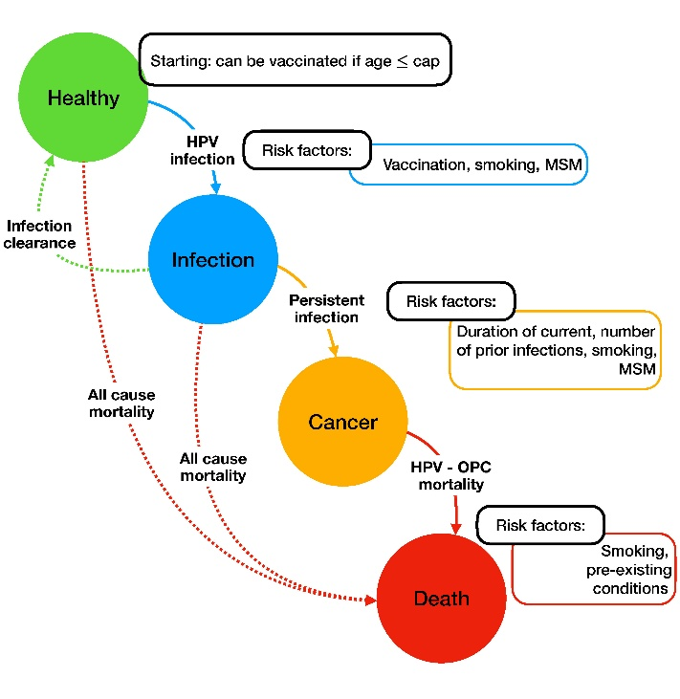
Aim 2: Model the potential public health benefit of extending the age of universal HPV vaccination eligibility in the VHA population: Although HPV vaccination effectively prevents oral HPV infection and HPV-associated OPC, its population-level benefits have not been assessed within the unique demographic, behavioral, and healthcare context of Veterans. Existing studies in the general U.S. population underestimate the potential benefit of vaccination in Veterans because they do not account for later entry into the healthcare system, higher smoking prevalence, greater comorbidity burden, and absence of screening for OPC. As many Veterans enter the VHA between ages 26 and 45—after the traditional vaccination window—expanding vaccination eligibility within this age range may provide meaningful reductions in HPV infection and OPC incidence. To evaluate this possibility, we will use a Veteran-specific microsimulation model (MM) to simulate the health impact of alternative vaccination age thresholds, incorporating real-world demographic, behavioral, and VISN-level data obtained in Aim 1.
Figure 4. Schematic of HPV natural history

Experimental Approach: The MM simulates HPV transmission, persistence, and OPC outcomes within the Veteran population. Each “agent” represents an individual Veteran characterized by attributes derived directly from Aim 1—age, sex, vaccination status, smoking, alcohol use, and VISN affiliation. Agents move through five health states (Healthy, HPV Infection, Persistent Infection, HPV-associated OPC, Death) according to probabilistic rules that reflect these risk factors (Figure 4). Vaccination reduces the probability of HPV infection and persistence, whereas smoking and alcohol use increase progression risk. This structure captures both individual heterogeneity and population-level dynamics across the VHA system.
The model will be parameterized with Aim 1 data, reflecting the distributions of age, sex, race/ethnicity, behavioral risk factors, vaccination prevalence, and adherence observed among Veterans aged 26–45 from 2018–2025. A synthetic cohort of 10 000 agents, calibrated to reflect the demographic makeup of the national Veteran population, will be generated by probabilistic sampling from these empirical distributions. Annual time steps over a lifetime horizon will capture near- and long-term effects of vaccination expansion. We will evaluate five policy scenarios: maintaining eligibility through age 26 (status quo) and expanding eligibility to ages 30, 35, 40, and 45. For each scenario, the MM will estimate annual and cumulative numbers of HPV infections, persistent infections, OPC cases, and deaths.
Data Inputs and Calibration: Model inputs will derive primarily from Aim 1 to ensure internal consistency and Veteran specificity. The agent population will be initialized using joint distributions for demographic (age, sex, race/ethnicity, VISN) and behavioral (smoking, alcohol, comorbidity) factors and vaccination attributes (ever vaccinated, dose count, adherence ≥2 doses). Initialization will employ stratified sampling so that marginal totals and cross-tabs (e.g., age × VISN, smoking × vaccination) reproduce Aim 1 data. Baseline vaccination prevalence and adherence will be assigned separately by VISN to reflect observed heterogeneity.
Transition probabilities between health states (Healthy → Infection → Persistence → OPC → Death) will be guided whenever possible by associations quantified in Aim 1; parameters not available from Aim 1 will be imported from published literature. Parameters for vaccine efficacy in the 26–45 age group will be derived from randomized clinical trial data demonstrating robust immunogenicity and protection against persistent infection in mid-adult populations. To account for potential uncertainty regarding real-world effectiveness in Veterans, we will perform sensitivity analyses varying vaccine efficacy parameters across a range of plausible values. Calibration multipliers will then be applied so that model outputs reproduce overall and VISN-specific levels observed in Veterans. Calibration will proceed in two stages: (1) structural calibration, aligning the baseline year with Aim 1 targets for vaccination, smoking, and alcohol prevalence; and (2) dynamic calibration, refining imported transition probabilities so simulated trajectories mirror Aim 1 temporal patterns. Uncertainty will be addressed via 1,000 Monte Carlo iterations, reporting means and 95 % simulation intervals.
Simulation Scenarios: Primary outcomes will include reductions in OPC incidence, averted cancer deaths, and gains in QALY. Under the status quo scenario, Monte Carlo simulations (1,000 iterations) will be performed on the calibrated Veteran cohort to estimate the annual and cumulative numbers of HPV infections, persistent infections, and HPV-associated OPC cases and deaths across a 30-year projection period. Results will be summarized at the national and VISN levels, with standard errors and uncertainty bands calculated from simulation outputs. These baseline results will establish the expected disease trajectory if current vaccination practices remain unchanged.
We will then model a series of expanded vaccination eligibility scenarios in which HPV vaccination is extended to Veterans up to ages 30, 35, 40, and 45. For each scenario, vaccination coverage among newly eligible Veterans will be initialized based on age-specific vaccination and adherence rates derived from Aim 1, with additional assumptions about future uptake rates. Higher uptake will reduce the probability of transitioning from the Healthy to HPV Infection state, thereby decreasing the cumulative number of infections and subsequent OPC cases. Vaccine effectiveness for these mid-adult cohorts will be parameterized using end-of-study clinical trial data confirmed to prevent persistent infection and disease in adults aged 24–45. Outcomes will be compared across all scenarios to quantify relative reductions in infection prevalence, cancer incidence, and mortality.
Additionally, we will conduct behavioral sensitivity scenarios to assess how changes in vaccination rates over time impact projected outcomes. We will model both increases in vaccine uptake (reflecting improved outreach or VISN-specific programs) and decreases in vaccination rates (reflecting reduced access or declining public confidence). A decline in vaccination rates will increase the probability of HPV infection and persistence, leading to higher simulated OPC incidence. Comparing these opposing trends will help quantify how fluctuations in vaccination behavior could influence long-term cancer prevention outcomes.
Interpretation and Deliverables: Extending HPV vaccination beyond age 26 is expected to produce stepwise reductions in HPV infection, persistence, and OPC incidence, with the greatest benefit under an age 45 expansion. Impact will vary by VISN, depending on baseline vaccination coverage and behavioral risk profiles. Deliverables will include a documented MM framework hosted on the VA Informatics and Computing Infrastructure (VINCI), VISN-specific reports detailing modeled reductions in disease, and a national policy brief summarizing the projected public health benefits of expanded vaccination eligibility. Together, these results will provide the VHA with a Veteran-specific, data-driven foundation for evaluating and implementing equitable, preventive HPV vaccination strategies across the health care system.

IMPLEMENTATION AND DISSEMINATION PLAN: This pilot will generate foundational, Veteran-specific evidence on HPV vaccination within the VHA, including national vaccination rates, vaccination patterns among mid-adult Veterans, and early estimates of vaccination initiation among unvaccinated Veterans entering VHA primary care. These descriptive data will provide the first system-wide assessment of who is getting vaccinated, where gaps exist, and which VISNs have the greatest unmet need. Using these findings, we will develop and test the feasibility of a Veteran-specific simulation framework to explore how expanded HPV vaccination eligibility could influence future cancer prevention efforts. The pilot will produce preliminary results needed to support larger-scale modeling studies and inform future Merit and R01 applications.
This project directly supports VHA priorities in cancer prevention, equitable access, and population health improvement. By identifying demographic, behavioral, and geographic barriers to HPV vaccination among mid-adult Veterans, the pilot will highlight differences in preventive care, particularly in rural and low-access VISNsthat can be addressed through targeted primary care or CBOC–level interventions. Early simulation outputs will offer proof-of-concept estimates of potential health benefits, providing VHA leadership with actionable, preliminary data to guide prevention initiatives.
Pilot results will be shared with the National Oncology Program Office, VISN Preventive Health Leads, the Office of Rural Health, and the Office of Health Equity to inform planning around mid-adult vaccination outreach. We will prepare a brief, actionable report summarizing VISN-level vaccination patterns and potential intervention targets. Findings will also be disseminated through peer-reviewed publications, VA Research Week presentations, and collaboration with the VHA Oropharyngeal Cancer Working Group. All analytic code will be maintained within VINCI for future development.
Aim 1 will generate the first comprehensive, VISN-level profiles of HPV vaccination prevalence and identify key demographic, behavioral, and geographic gaps in uptake. These short-term results will provide immediate targets for VISN-specific initiatives and establish the core dataset required for subsequent modeling. Aim 2 will focus on building and calibrating a preliminary Veteran-specific MM to test the feasibility of projecting HPV infection and OPC outcomes under expanded vaccination scenarios. This pilot model will serve as a prototype for future, fully powered economic and policy evaluations.

PROJECT MANAGEMENT: Leadership and Governance: Dr. Zevallos will hold standing project meetings every two weeks to review progress, address challenges, and coordinate analysis and dissemination activities. Dr. Angela Mazul will play a key leadership role in Aim 1 and throughout the project. She will co-lead cohort construction, oversee the development and coding of essential epidemiologic variables, and direct the integration of demographic, behavioral, and contextual measures from the VHA CDW. Dr. Soumik Purkayastha will oversee analytic pipelines, statistical modeling, and simulation calibration within the VINCI environment. Dr. Maria Mor will manage all VA data operations, including cohort construction, data quality checks, variable harmonization, and compliance with VA data governance standards. Dr. Jessica Maxwell will provide clinical guidance, ensure translational relevance, and support the interpretation of vaccination patterns and HPV-OPC burden estimates. Workflow and Coordination: The project will follow a structured plan with coordinated milestones across aims as detailed in Table 1. In Year 1 and 2, the team will finalize phenotype definitions, complete data extraction, construct analytic files, and finish Aim 1 analyses. Findings from Aim 1 will be directly used as inputs for Aim 2 simulations. In year 2, the team will complete model calibration, validate simulation outputs, and perform all public health benefit and economic analyses for Aim 2. Data will be stored and analyzed solely within VINCI, adhering to all VA privacy and security guidelines. The investigators will jointly review analytic code, model assumptions, and data outputs to ensure reproducibility and accuracy.
Table 1. Project Timeline
 | Year 1 |  |  |  | Year 2
Activity / Milestone | Q1 | Q2 | Q3 | Q4 | Q1 | Q2 | Q3 | Q4
Administrative & Regulatory Approvals
Data Extraction & Cohort Construction
Aim 1: Analyses
Aim 1: VISN-Level Mapping
Aim 2: MM Parameterization
Aim 2: Simulation of Scenarios
Aim 2: Analysis of Outcomes
Integration & Policy Translation
Dissemination

PATH TO FUTURE MERIT
Findings from this pilot will directly inform a subsequent VA Merit Review focused on implementing scalable HPV vaccination strategies for all age-eligible Veterans. By identifying VISN-specific vaccination gaps, barriers, and the projected benefits of expanded eligibility, the pilot will lay the groundwork for a larger trial aimed at closing coverage gaps, reducing cancer risk, and improving health equity. The Merit will begin with mixed-methods formative work in high-need VISNs (identified by the pilot) to assess multilevel determinants of HPV vaccine uptake. Using both quantitative data and stakeholder input, the team will collaborate with Veterans, primary care teams, pharmacists, and operational leaders to co-design strategies tailored to local needs. Examples may include electronic health record prompts for clinicians, pharmacist-led vaccine delivery, nurse-driven outreach, and Veteran-facing reminder/recall systems. These interventions will be refined using implementation science frameworks such as Consolidated Framework for Implementation Research (CFIR) or Reach, Effectiveness, Adoption, Implementation, Maintenance (RE-AIM) to ensure fit, feasibility, and sustainability. The Merit will then conduct a pragmatic, multi-site implementation trial using a Hybrid Type II design. The trial will test the effectiveness of VISN-adapted multicomponent implementation bundles to increase HPV vaccination rates among eligible Veterans. Key outcomes will include reach (eligible Veterans offered vaccination), adoption (use by clinics), and changes in vaccination rates. The study will also monitor implementation fidelity and explore factors affecting real-world performance across diverse settings. To estimate long-term value, a parallel modeling component will simulate the health and economic impact of improved HPV vaccination coverage, including reductions in HPV infections, cancer incidence, and treatment costs. These projections will aid leadership in making decisions on broader rollout and resource allocation. Finally, the Merit will evaluate sustainability and health equity. It will investigate whether gains in vaccination rates persist after active support ends and if improvements benefit all Veteran populations equitably across race, sex, rurality, and VISN. Study findings will inform the development of an HPV vaccination implementation toolkit and contribute to VISN-level monitoring dashboards. By translating pilot findings into targeted, stakeholder-informed strategies and testing them in a pragmatic trial, the Merit will build the evidence needed for system-wide expansion. It will advance VHA priorities in cancer prevention, equitable access, and data-driven population health.
REFERENCES
1. Ang KK, Harris J, Wheeler R, et al. Human papillomavirus and survival of patients with oropharyngeal cancer. N Engl J Med. Jul 1 2010;363(1):24-35. doi:10.1056/NEJMoa0912217
2. Chaturvedi AK, Engels EA, Pfeiffer RM, et al. Human papillomavirus and rising oropharyngeal cancer incidence in the United States. J Clin Oncol. Nov 10 2011;29(32):4294-301. doi:10.1200/JCO.2011.36.4596
3. Van Dyne EA, Henley SJ, Saraiya M, Thomas CC, Markowitz LE, Bernard VB. Trends in Human Papillomavirus–Associated Cancers — United States, 1999–2015. MMWR Morb Mortal Wkly Rep. 2018;67:918-924.
4. Agalliu I, Gapstur S, Chen Z, et al. Associations of Oral α-, β-, and γ-Human Papillomavirus Types With Risk of Incident Head and Neck Cancer. JAMA Oncology. 2016;2(5):599-606. doi:10.1001/jamaoncol.2015.5504
5. Gillison ML, Chaturvedi AK, Anderson WF, Fakhry C. Epidemiology of Human Papillomavirus-Positive Head and Neck Squamous Cell Carcinoma. J Clin Oncol. Oct 10 2015;33(29):3235-42. doi:10.1200/JCO.2015.61.6995
6. Meites E, Szilagyi PG, Chesson HW, Unger ER, Romero JR, Markowitz LE. Human Papillomavirus Vaccination for Adults: Updated Recommendations of the Advisory Committee on Immunization Practices. MMWR Morb Mortal Wkly Rep. Aug 16 2019;68(32):698-702. doi:10.15585/mmwr.mm6832a3
7. Boersma P, Black LI. Human Papillomavirus Vaccination Among Adults Aged 18-26, 2013-2018. NCHS Data Brief. Jan 2020;(354):1-8.
8. United States Department of Veterans Affairs. Office of Rural Health: Rural Veteran Health Care Challenges. Accessed August 9, 2020. https://www.ruralhealth.va.gov/aboutus/ruralvets.asp
9. Washington DL. National Veteran Health Equity Report 2021. Focus on Veterans Health Administration Patient Experience and Health Care Quality. VHA Office of Health Equity; 2022. https://www.va.gov/HEALTHEQUITY/docs/NVHER_2021_Report_508_Conformant.pdf
10. Zevallos JP, Kramer JR, Sandulache VC, et al. National trends in oropharyngeal cancer incidence and survival within the Veterans Affairs Health Care System. Head Neck. Jan 2021;43(1):108-115. doi:10.1002/hed.26465
11. Kim JJ, Simms KT, Killen J, et al. Human papillomavirus vaccination for adults aged 30 to 45 years in the United States: A cost-effectiveness analysis. PLoS Med. Mar 2021;18(3):e1003534. doi:10.1371/journal.pmed.1003534
12. Laprise JF, Chesson HW, Markowitz LE, et al. Effectiveness and Cost-Effectiveness of Human Papillomavirus Vaccination Through Age 45 Years in the United States. Ann Intern Med. Jan 7 2020;172(1):22-29. doi:10.7326/m19-1182
13. Pratama AP, Chen SF, Liao SC, Su WC, Yu JH. Incremental net benefit of extending human papillomavirus vaccine to boys in oropharyngeal cancer burden: Meta-analysis of cost-effectiveness studies. J Dent Sci. Oct 2024;19(4):2045-2056. doi:10.1016/j.jds.2024.05.032
14. Castle PE. Prophylactic human papillomavirus vaccination for prevention of oropharyngeal cancer in older men: is the juice worth the squeeze? J Natl Cancer Inst. Apr 11 2023;115(4):349-351. doi:10.1093/jnci/djad025
15. Choi SE, Choudhary A, Huang J, Sonis S, Giuliano AR, Villa A. Increasing HPV vaccination coverage to prevent oropharyngeal cancer: A cost-effectiveness analysis. Tumour Virus Res. Jun 2022;13:200234. doi:10.1016/j.tvr.2021.200234
16. Saxena K, Dawson RS, Cyhaniuk A, Bello T, Janjan N. Clinical and economic burden of HPV-related cancers in the US veteran population. Journal of Medical Economics. 2022/12/31 2022;25(1):299-308. doi:10.1080/13696998.2022.2041855
17. Jacobson JJ, Epstein JB, Eichmiller FC, et al. The cost burden of oral, oral pharyngeal, and salivary gland cancers in three groups: commercial insurance, Medicare, and Medicaid. Head Neck Oncol. 2012;4:15. doi:10.1186/1758-3284-4-15
18. Zevallos JP, Sandulache VC, Hamblin J, et al. Impact of race on oropharyngeal squamous cell carcinoma presentation and outcomes among veterans. Head Neck. Jan 2016;38(1):44-50. doi:10.1002/hed.23836
19. Nobel T, Rajupet S, Sigel K, Oliver K. Using Veterans Affairs Medical Center (VAMC) data to identify missed opportunities for HPV vaccination. Hum Vaccin Immunother. 2019;15(7-8):1878-1883. doi:10.1080/21645515.2018.1559684
20. Freedman MS, Hunter P, Ault K, Kroger A. Advisory Committee on Immunization Practices Recommended Immunization Schedule for Adults Aged 19 Years or Older — United States, 2020. MMWR Morb Mortal Wkly Rep. 2020;69:133-135.
21. Halista CE, Kline RJ, Bepko J. Understanding Barriers to HPV Vaccination: Perspectives From Air Force Family Medicine Physicians and Active Duty Air Force Males. Mil Med. 2020;185(5-6):e878-e886. doi:https://doi.org/10.1093/milmed/usz403
22. Masel J, Deiss RG, Wang X, et al. Seroprevalence and seroincidence of herpes simplex virus (2006-2010), syphilis (2006-2010), and vaccine-preventable human papillomavirus subtypes (2000-2010) among US military personnel. Sex Transm Dis. May 2015;42(5):253-8. doi:10.1097/olq.0000000000000277
23. Brown DW. Smoking prevalence among US veterans. Journal of general internal medicine. Feb 2010;25(2):147-9. doi:10.1007/s11606-009-1160-0
24. Odani S, Agaku IT, Graffunder CM, Tynan MA, Armour BS. Tobacco Product Use Among Military Veterans - United States, 2010-2015. MMWR Morb Mortal Wkly Rep. Jan 12 2018;67(1):7-12. doi:10.15585/mmwr.mm6701a2
25. Wang ZJ, Dhanireddy P, Prince C, Larsen M, Schimpf M, Pearman G. 2019 Survey of Veteran Enrollees’ Health and Use of Health Care – Data Findings Report. Accessed August 9, 2020. https://www.va.gov/HEALTHPOLICYPLANNING/SOE2019/2019_Enrollee_Data_Findings_Report-March_2020_508_Compliant.pdf
26. Chidambaram S, Chang SH, Sandulache VC, Mazul AL, Zevallos JP. Human Papillomavirus Vaccination Prevalence and Disproportionate Cancer Burden Among US Veterans. JAMA Oncol. May 1 2023;9(5):712-714. doi:10.1001/jamaoncol.2022.7944
27. United States Department of Veterans Affairs. National Center for Veterans Analysis and Statistics: VA Utilization Profile FY 2017. Accessed August 9, 2020. https://www.va.gov/vetdata/docs/Quickfacts/VA_Utilization_Profile_2017.pdf
28. McGinnis KA, Brandt CA, Skanderson M, et al. Validating smoking data from the Veteran's Affairs Health Factors dataset, an electronic data source. Nicotine Tob Res. 2011;13:1233-1239.
29. Golden SE, Hooker ER, Shull S, et al. Validity of Veterans Health Administration structured data to determine accurate smoking status. Health Informatic J. 2020;26(3):1507-1515.
30. U.S. Department of Agriculture. 2020 Rural-Urban Commuting Area Codes. In: Service ER, editor. July 2025.
31. Muluk S, Sabik L, Chen Q, Jacobs B, Sun Z, Drake C. Disparities in geographic access to medical oncologists. Health Serv Res. Oct 2022;57(5):1035-1044. doi:10.1111/1475-6773.13991
32. Luo W, Qi Y. An enhanced two-step floating catchment area (E2SFCA) method for measuring spatial accessibility to primary care physicians. Health Place. Dec 2009;15(4):1100-7. doi:10.1016/j.healthplace.2009.06.002

